# **Historical Events: The Conquest of the Desert**

# **Name:**

*Instructions:* Read the event(s) assigned to your group and answer the questions that follow. Be prepared to share your answers with the class.

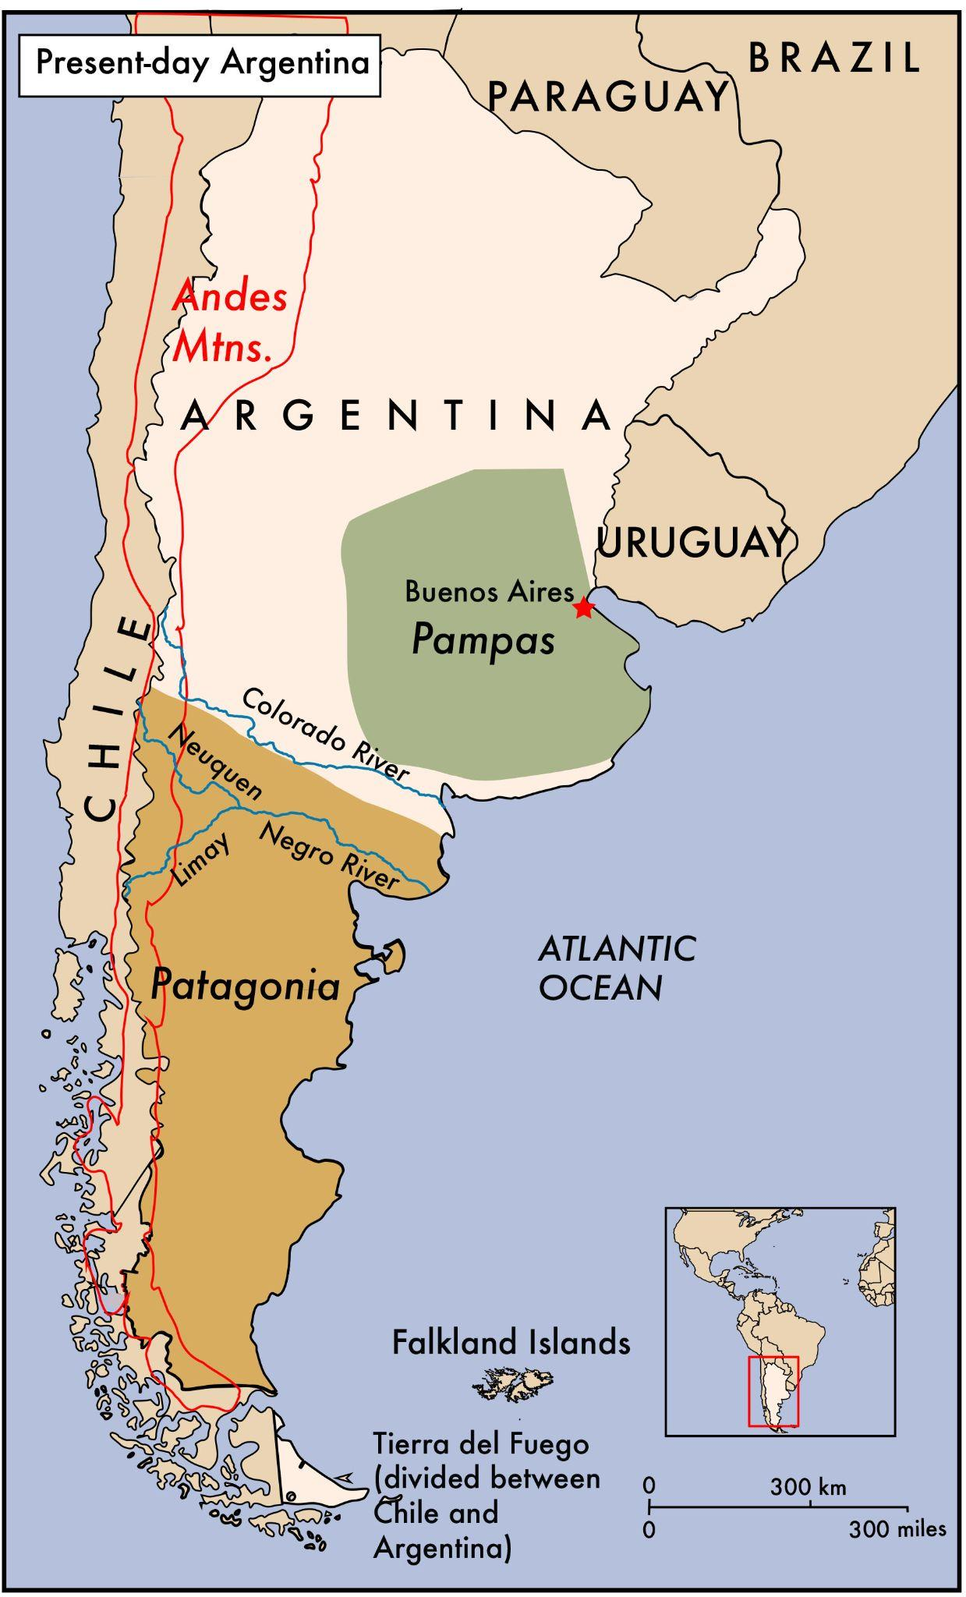

***Note on Disturbing Content***

*This reading contains content that may be upsetting for readers. It describes physical and psychological violence, and might be particularly intense for students with a personal connection to the topic. It is important to be sensitive to your classmates and the ways in which this might be a difficult topic to study.*

The country of Argentina gained its independence from Spain in 1816. Argentina’s newly unified central government wanted to expand its control of land from the coastal areas into more inland areas inhabited by Native groups. This was a way of increasing agricultural and commercial production and providing land to new immigrants of European origin, whom government officials saw as superior to Native people. Many Argentinian officials believed in eugenics, a racist and false theory claiming that there are racial differences in humans. Officials wanted to eliminate the possibility of mixing with Native groups because they believed the groups were inferior and prevented the country from developing economically. In addition, Argentines hoped that by taking land further west they would prevent the neighboring country of Chile from expanding its borders.

Continuing the long history of colonizing Native land to expand its borders, between 1878 and 1885 the Argentine government began a military campaign in the regions of Pampas and Patagonia. General Julio Argentino Roca, the national minister of defense who became the president of Argentina from 1880-1886 and again from 1898-1904, started the campaign.

During this campaign, the army was authorized to execute prisoners, including women and children. Families of Native groups were separated. Children were often kidnapped or forcibly removed from their parents. They were relocated to “concentration camps’’ in different parts of Argentina or forced to work as servants for wealthy Argentines. Some were brought back to the capital city as curiosities and forced to sit in state fairs for urban white residents to observe. Native men and women were also separated, and Native women were often raped or forced into marriage with white soldiers. Argentines justified these separations by saying that they were introducing Native children to a higher form of civilization. The Argentine government’s actions killed at least one thousand Native people and forced fifteen thousand from their homes. The government took thirty-seven thousand acres of land for wealthy white investors.

**Questions**

1. Were the Argentine government’s actions a genocide? Give at least two reasons from the text to support your view.

2. What standards from Article II of the Genocide Convention apply to determine if this event was a genocide?

3. What additional information would you like to have about the “Conquest of the Desert”?